Final
Vallecito Dam and Reservoir, Bayfield, Colorado
Debris Cleanup Needs Study
January 8, 2025
By: Ken Beck, PRID Superintendent

Table of Contents
Section Page
1) Debris Cleanup Needs Summary…………………………………………………………. 1
2) Project Background……………………………………………………………………….. 1
3) Issue Summary……………………………………………………………………………. 1
4) Recommendation………………………………………………………………………….. 2
5) Federal Emergency Management Agency (FEMA)…..…………………………………… 3
6) Cascade Timber Salvage……………………………………………………………………4
7) Recommendation - December 9, 2025, Bureau of Reclamation
/ Pine River Irrigation District.…………….…… …………………………………………4

8) Quotes on Protective Debris Buoy Line.………………………………………………….. 6

9) Vallecito Flood Recovery (NRCS/UPFPD).……………………………………………….. 7

10) Summary.…………………………………………………………………………………..7
11) Updates.…………………………………………………………………………………….8
12) Appendices.……………………………………………………………………………….. 9
13) Appendix A. Hydrology Record of October the 2025 Year Flood Event…………………10
14) Appendix B. Select Photos of the Debris Accumulation in Vallecito Reservoir from the
Flood Event..………………………………………………………………………………12
15) Appendix C. Cascade Timber Salvage’s Bid Proposal and Related Information..………. 19
16) Appendix D. Bureau of Reclamation / Pine River Irrigation District November 13, 2025
Zoom Conference Call..………………………………………………………………….. 29
17) Appendix E. Protective Debris Buoy Line...………………………………………………32
18) Appendix F. Summary of January 8, 2026, Meeting among NRCS/UPFPD, BOR
and PRID Representatives – Vallecito Reservoir Debris Management and Funding
Opportunities, October 2025 100 Year Flood Event..………………………………………….33

Vallecito Dam and Reservoir, Bayfield, Colorado
October 2025 100-Year Flood Event
(December 22, 2025)

Debris Cleanup Needs Summary

Project Background
The Pine River Project (Project) was authorized by Congress in the Department of Interior Appropriation Act of 1937, which was approved on June 22, 1936. The project was approved by the President on June 17, 1937, under the provisions of section 4 of the Act of June 25, 1910 (36 Stat. 835), subsection B, and section 4 of the Act of December 5, 1924 (43 Stat. 701). The Project’s authorized purpose is twofold: provide supplemental irrigation water to both the Southern Ute Indian Tribe and non-Indian water users and flood control. The Project serves approximately 69,000 acres of irrigable land, which includes supply to the Southern Ute Indian Tribe through an agreement with the Bureau of Indian Affairs. In addition, the Project produces hydroelectric power through a private facility and includes recreational facilities.
Construction of Vallecito Dam, the primary feature of the Pine River Project, was substantially completed in October 1941. The Bureau of Reclamation (Reclamation/BOR) maintains ownership of the Project facilities with operation, maintenance and replacement responsibility transferred to the Pine River Irrigation District (PRID) via the 1940 Repayment Contract between the United States and PRID, as amended.

Issue Summary
Immediately following the historic flooding that occurred in the Los Pinos (Pine River) drainage basin between October 9th through the 15th, 2025, Vallecito Dam received minimal impact as the concentration of the larger debris field was located at the north-end of the Reservoir. Vallecito Reservoir rose approximately 25 feet during the flooding and runoff period. (See Appendix A for a hydrology record of the flood event.) Debris flows from the supplying creeks and rivers began to accumulate along the Vallecito Dam within days after the flood event. While debris collection does not pose an imminent risk to Project Facilities, it cannot be left to accumulate indefinitely. Debris removal is part of a typical operation and maintenance program at this and other Reclamation facilities to ensure infrastructure operation and protection. Typically, removal of woody debris along the face of Vallecito Dam has been required at irregular intervals as accumulation levels build over time until enough has collected to necessitate removal. The historically high flows in Vallecito Creek and the Los Pinos River, cutting of banks, felling of trees, and collection of other material along stream banks has severely expedited accumulation of debris, requiring monitoring and frequent attention. (See Appendix B. for select photos of the debris accumulation in Vallecito Reservoir from the October 2025 100-year flood event.) (Note -the first four photos show the debris confined to the north-end of the Reservoir. Photo 2 shows scaring of the lakebed from vehicular trespass. Photo 5 shows the concentration of debris at the north-end has significantly decreased. Photo 6 shows that the debris has disbursed and migrated to the Spillway Inlet at the south end of the Lake.)
As debris accumulates along a dam, physical removal using barges, cranes, excavators, and manual labor is conventional. Trash booms are generally designed to manage floating debris and aren’t designed to manage submerged debris. If captured floating debris is not removed, then it may become waterlogged and then submerge, becoming more difficult to remove and potentially impacting the outlet works intake structure. Physical debris removal is labor intensive, time consuming, and costly, but is a necessity to protect Project features. During low reservoir levels or periods when sediment and debris arrive at an outlet works intake, woody debris can rack on grated intakes, impacting reservoir operations. After the woody debris blocks the intake, sediment then deposits behind the racked members, beginning the process of limiting sediment passage during flushing and sluicing, and increasing the potential for eventual burial of the intake.
Recreation on Vallecito Reservoir including boating, fishing, swimming, etc. is commonplace in the summers. Reclamation’s 1984 recreation management agreement with PRID states that PRID has assumed responsibility for “the safety of the general public, including, but not limited to, the disposal of floatable debris in the reservoir and undermined or fallen trees within the reservoir area necessary to maintain the area in a condition suitable for use by the public.”
As noted in the attached photos, debris in the reservoir is already accumulating following the October storm event and more debris is anticipated to collect during spring 2026 runoff season as flows increase again and release material collections along stream banks and obstacles that will have held debris in place over the winter.

Recommendation
It became apparent that before plans for debris remedial actions could be developed on how best to approach the management and cleanup, a calculated estimate of the amount of debris that had accumulated in the Reservoir would be helpful. During the initial onsite tours of the impacted flood area, La Plata County Sheriff Sean Smith and PRID Superintendent Ken Beck exchanged thoughts and ideas on how best to calculate the amount of debris that had collected in Vallecito Reservoir. Sheriff Smith offered the services of his Unmanned Aerial Systems Unit, Program Manager (Drone Pilot), Deputy Henrik Krog. Krog made two drone flights of Vallecito Reservoir, on October 21, and November 5, 2025. At the conclusion of each flight, Krog and Beck calculated the estimated total debris surface area. The flight on October 21 yielded a range between five (5) and six (6) acres of debris in the reservoir. The flight on November 5, yielded a range between six (6) and seven (7) acres. The biggest difference in the 15-day period that separated the two flights was that the wind and natural current flow into Vallecito Reservoir, from Vallecito Creek and the Pine River, had dispersed the debris from its concentration at the north-end to depositing debris around the Lake to Vallecito Dam to the south end of the Lake as noted above.

Federal Emergency Management Agency Process
In preparation for submitting this document, as part of the initial Federal Emergency Management Agency (FEMA) process, the PRID and Bureau of Reclamation (BOR) managers in Durango, Colorado held a conference call on Wednesday, November 5, 2025, to assess the debris management situation. To avoid debris settlement over the winter and risk clogging of the outlet works intake and provide protection of recreators next summer, it was recommended that at least two major debris collection efforts be undertaken as part of this cleanup program: one in the winter of 2025/2026 and one in the late-spring/early-summer of 2026. It was also suggested that there may be additional collection needs beyond this recommendation, however, these could likely be included in PRID’s typical operation and maintenance program following this more substantial effort.
With the passing of time, and input form FEMA experts, it became apparent that the criteria of “imminent danger” was missing as a needed requirement for requesting and securing financial assistance for the removal of debris in the reservoir as part of the short-lived FEMA process. Yes, the debris poses a potential future problem, however, Reclamation is not concerned it will. However, the problem could not be classified as “imminent.” Consequently, if PRID were to spend shareholder savings, that had been set aside for the repairs and replacement of the Project’s failing spillway, this money would have a near “zero” chance of being reimbursed as part of the FEMA financial assistance/relief process. The PRID BOD took the position that they were not going to encumber PRID’s shareholders by subsidizing the entire financial responsibility associated with the debris removal and management efforts, especially when a host of other interests and entities would directly benefit from the cleanup (i.e., the recreation community, Vallecito Power Plant, downstream municipalities, etc.).
As it became evident that relief funding from the FEMA effort was not going to materialize, Superintendent Beck, initiated conversations with Tom McNamara, Colorado Department of Public Safety (CDPS), official. McNamara and Beck discussed, on occasions that the most likely and promising opportunity for PRID to acquire funding assistance for the Project facilities debris management and removal endeavor, would be in the next phase of the emergency management effort - The Long-Range Recover Phase. McNamara explained that in this phase, the Natural Resource Conservation Service (NRCS) will team-up with a local governmental organization, like La Plata County, Colorado, government, for several months of a collaborative effort to assist with the impacts of the October flooding, beyond what the short-lived FEMA process is designed to accomplish. At several of the public meetings McNamara advised the participants not to do any remediation work (including filling potholes) without extensive documentation, including detailed pictures of any and all remediation work. Without this extensive documentation, financial relief, associated with the FEMA process would not be forthcoming.

Cascade Timber Salvage
At this same time, on November 5, 2025, a bid was submitted by a local forestry business, “Cascade Timber Salvage,” for the removal of the debris accumulated in the Reservoir. The bid was for approximately $310,000.00. The focus of the effort would be in the collecting, staging, and removal of the debris in an approximate 1.89-mile area at the north-end of the Reservoir using heavy specialized forestry equipment. Within days of receiving the Cascade Timber Salvage Proposal, it became outdated with the migration of debris that was focused days earlier at the north-end of the Lake, that now was more evenly distributed around its perimeter. Once again, the PRID BOD decided against funding this bid submittal because the likelihood of being reimbursed for the effort was non-existent. (See Appendix C. for a copy of the Cascade Timber Salvage bid proposal.)
On Thursday, November 13, 2025, the PRID and BOR representatives conducted a Zoom conference call with BOR’s, Western Colorado Area Office managers to again discuss the Vallecito Reservoir debris cleanup recommendations with BOR Management, the owners of the federal estate, and the governing body having jurisdiction of same. Several aspects of the debris management and cleanup were discussed in detail including the need for a NEPA compliance effort associated with whatever clean-up process that would be recommended. (See Appendix D. for a copy of the November 13, 2025, notes of the Zoom conference call.) From that Zoom meeting the BOR and PRID developed a recommendation that addressed the most reasonable approach to the debris management/removal process for a BOR/PRID financial and environmental compliance perspective. This recommendation is posted on the La Plata County Emergency Response website.

Recommendation
Pine River Irrigation District’s (PRID) Management of the Debris In Vallecito Reservoir Resulting From the October 2025 Flood Event
(December 9, 2025, Update)

The October 2025, 100-year-flood-event resulted in approximately five (5) to seven (7) acres of debris being flushed into Vallecito Reservoir (Reservoir). The Reservoir, when full, covers
approximately 2,720 acres.

The debris covers less than 5 percent of the total surface area of the Reservoir. However, the debris raises two concerns for PRID and Bureau of Reclamation (BOR):
1) The potential for restricting and/or plugging the intake structure at the south-end of the Reservoir. Thus, the potential for impacting 2025 and 2026 flood control measures, irrigation and municipal and industrial releases, and the generation of electrical power at the Power Plant in 2026.
2) Safety issues with the upcoming 2026 boating / recreation season. PRID and BOR have conferred on the above issues several times. It was discussed that no additional debris removal actions were taken in the flooding events of 2006 and 2013. A large percentage of the debris will settle out at the Reservoirs high-water line at approximately 7,665 feet. Wood gathering efforts (fire and decorative wood seekers) can and will move a significant amount of debris as seen in previous flooding events.
The following debris management actions have been discussed between BOR and PRID. However, Reclamation will need to review and approve any debris boom installation and is not recommending this, but willing to review PRID’s position on the protective debris buoy line or boom installation. BOR has noted that the installation of a protective buoy line can create additional problems that will need to be evaluated prior to taking action.
1) PRID may install a debris management buoy-line in front of the three (3) Radial Gates (flood control gates), then east on the dam face just beyond the Control House located on the east side of Vallecito Dam Road. This configuration will protect the Outlet Works Intake Structure from debris accumulation. Note – On October 15, 2025, the BOR mobilized a Sonar Imaging Unit to make sure that new debris was not collecting on the intake screen. The imaging confirmed that that was the case – no debris from the October 2025 event is accumulating on the screen. Unfortunately, false public rumors to the contrary abound!
2) PRID will add two budget line items, relating to debris management, to it’s 2026 draft budget proposal:
First ~ Summer Crew – Debris Removal - $40,000. PRID will take a less costly / aggressive approach in removing the debris, verse an aggressive approach which will likely result in negative environmental impacts from the use of heavy equipment operating on the fragile lakebed. At present, erosion and scaring at the north end of the lakebed has been problematic due to trespass issues. Using heavy equipment, in the debris removal process will likely exacerbate the issue.
Second ~ The purchase / installation of approximately, one-half of the aforementioned debris buoy line to protect the integrity of the intake structure - $60,000. Note: The above budget line-item recommendations and Summer Crew – Debris Removal suggested budget line items have not been approved by the PRID BOD or our shareholders.
Third ~ With BOR’s input, PRID will launch a spring public notification effort warning boaters to “Be aware of the possibility of floating debris from the October 2025 100-year-flood-event. Boat at your own Risk.” This approach complies and conforms with our current policy regarding boating at Vallecito Reservoir “Boat At Your Own Risk.” Especially, with the drawdown of the lake in the later summer and early fall of the year with the ever-increasing appearance of islands on the east side of the lake as the water recedes.
Unfortunately, rumors abound that PRID turned down a grant funding offer for over $310,000.00 for debris cleanup/removal. Sadly, this statement is false and grossly misleading. PRID received an offer/bid from a highly respected, local, businessman to help with the debris cleanup. PRID researched the probability of being reimbursed by FEMA, and/or other federal sources if they paid the $310,000.00 contract amount. Our research indicated that the likelihood of federal reimbursement hovered near “zero percent.” The PRID BOD refused to lay this financial burden solely on the shoulders of its shareholders.
If you have any questions, please call Ken Beck, PRID Superintendent at 970-903-6051.
Thank You!

Quotes on Protective Debris Buoy Line
Two bid estimates were sought on the cost of a debris buoy line to protect the Intake Structure of the Outlet Work reference above. The estimates were provided by: 1) Kallen and Raelynn Elkins, Managers of Vallecito Marina via their contact sources associated with the Marina, and Val Gardner, Worthington Water Way Barriers, Business Development Manager. The PRID evaluated two buoy line protection options that varied in length from approximately 4,050 feet to 815 feet. Option 1 would run from the west to the east bank of the Vallecito Dam approximately 50 to 100 feet from the upstream surface of the dam. The advantage of this configuration is that it would not only protect the Intake Structure from debris, it would keep debris off the face of the dam for its entire length, including the Inlet Channel to the three Radial Gates. The second option would run the same alignment from west to east, but it would make a gradual 90 degree turn after it passed the Gate House on the Dam Road and would anchor back to the dam face. Option 1 was quickly dropped from further consideration for two reasons. First, it would impact fishing access along the face of the Dam that has been a popular fishing location over the years. Second, the cost of materials to construct the buoy line quickly became prohibitive. (See Appendix E. for additional details on the configuration, pricing, and evaluation of the two protective debris line options.)

Vallecito Flood Recovery (NRCS/UPFPD)
During the second week in December 2025, the initial phase of the FEMA process for the Vallecito Creek flooding event began drawing to a close as the second phase, the Long-Term Recovery Effort, or the “Vallecito Flood Recovery” started taking shape. The UPFPD began showing interest in becoming the local government entity, referenced above, in joining forces with the Natural Resources Conservation Service. The NRCS is a U.S. Department of Agriculture (USDA) agency. The project is part of the USDA Natural Resources Conservation Service Emergency Watershed Protection (EWP) program. “The purpose of the project is to reduce flood risk, stabilize streambanks, and protect homes and infrastructure following flood damage.” The roles of the participants are as follows: “NRCS (Federal Partner) – Provide federal funding, reviews and approves designs, and oversees compliance. Upper Pine Fire Protection District (Sponsor) – Manages the project, coordinates contractors and permits, and provides the required local cost share.” The scope of the project includes targeted debris and fallen tree removal to reduce flood hazards. All work follows approved environmental guidelines. An agreement was signed between the NRCS and UPFPD on Friday, December 19, 2025. The agreement has a timeline of just over 200 days. Mike Muir, an employee with the UPFPD, has been assigned as the Project Manager.”
UPFPD’s Chief, Bruce Evans, has explained that NRCS/UPFPD is looking for PRID to submit two subcontracts: one contract for the debris buoy line to protect the intake structure to the outlet works, and the second contract to hire and mobilize Cascade Forestry Salvage, referenced above, to initiate the debris clean-up in Vallecito Reservoir. Initial estimates are that PRID would pay NRCS (upfront) 25% of each subcontract (i.e., $110,000.00 X .25 = $27,500.00 (buoy line), and $310,000.00 X 25% = $77,500.00 (debris cleanup), for an approximate upfront payment of $105,000.00).

Summary
At present, the PRID has reached conceptual agreement with the BOR regarding acquiring a buoy line to protect the Intake to the Outlet Works. Before taking action, BOR will evaluate the advantages and disadvantages of installing the debris buoy/boom barrier. At present, PRID will take a less aggressive approach to the cleaning up of the debris in Vallecito Reservoir.
Reclamation is not currently concerned about operational risks posed by the debris to the Dam or appurtenant facilities, nor do they believe the clean-up is necessary.

If PRID chooses to pursue the purchase and installation of a debris buoy line, Reclamation will need to review and analyze potential impacts before approving the installation.
Please note that Reclamation’s concern is that a debris boom can sometimes cause more harm than good. It requires ongoing maintenance and cleaning, and depending on its orientation, it may result in more debris accumulating near the intake. These factors must be carefully considered.

The bid for approximately $310,000.00, from Cascade Timber Salvage, to remove the existing debris, was outdated within two weeks of its submittal. The bid is specific to an area of the Reservoir for approximately 1.89 mile linear section at the tip of the north-end of the Lake. The debris is now scattered over many more miles and comprising, though intermittently, nearly the circumference of the Reservoir shoreline. (The Reservoir shoreline is approximately12 miles in length.) It is anticipated that a revised bid, due to the significant increase in the cleanup area, will be substantially more expensive. BOR, based on its jurisdictional responsibilities for the PRP, if they choose to consider the NRCS/UPFPD subcontract offer further, will likely require an environmental impacts assessment associated with a grander scale cleanup effort that will undoubtedly encompass a much greater amount of the Reservoir shoreline and lakebed. In addition, BOR may also need to evaluate the need to implement a competitive bid process for a contract of this magnitude.
The second subcontract, the purchase and installation of the buoy line to protect the Intake Structure of the Outlet Works, holds promise for being a win, win for BOR, PRID, the Power Plant, municipal and industrial water users and the recreation community. However, as noted above BOR’s evaluation and approval of the installation is an essential element in moving forward.
PRID’s first order of business will be to get feedback on this document and the NRCS / UPFPD proposal from BOR – our partner in, and again, the entity with the jurisdictional responsibilities / authority over the Pine River Project.
End of Document

Updates
1) On Thursday, January 9, a meeting/zoom call was held at the PRID Office with Mike Muir, Project Manager for the NRCS/UPFPD Long Term Flood Recovery Effort, and BOR, and PRID representatives. The purpose of the meeting was to introduce the meeting participants and initiate discussion on the need and available funding for management of the debris that has accumulated in Vallecito Reservoir from the October 100-Year flood event. (See Appendix F.)

APPENDICES

APPENDIX A.
Hydrology Record of October 2025 Flood Event

Appendix A - Hydrology Record of October 2025 Flood Event
Vallecito Reservoir (Vallecito Creek and Pine River Respectively) 10/12/2025 @ 6:00 AM Readings
Date | Reservoir Elevation 9 AM | Elevation Change In Feet From Previous Day | Reservoir Storage 9 AM | Storage Change In Acre-Feet from Previous Day 9 AM | Reservoir Capacity Available (AF) 9 AM | Vallecito Creek Inflows (CFS) (Daily High) | Pine River Inflows (CFS) (Daily High)
Wed. 10/8/2025 | 7,619.48 |  | 29,298.00 |  | 96,202.00 | 108.00 | 73.40
Thur. 10/9/2025 | 7,619.56 | 0.08 | 29,404.00 | 106.00 | 96,096.00 | 86.90 | 69.90
Fri. 10/10/2025 | 7,619.90 | 0.34 | 29,858.25 | 454.25 | 95,641.75 | 1,030.00 | 574.00
Sat. 10/11/2025 | 7,622.31 | 2.41 | 33,214.75 | 3,356.50 | 92,285.25 | 6,680.00 | 2,850.00
Sun. 10/12/2025 | 7,628.82 | 6.51 | 43,537.75 | 10,323.00 | 81,962.25 | 2,070.00 | 1,860.00
Mon. 10/13/2025 | 7,631.21 | 2.39 | 47,750.75 | 4,213.00 | 77,749.25 | 2,560.00 | 1,740.00
Tues. 10/14/2025 | 7,635.42 | 4.21 | 55,719.25 | 7,968.50 | 69,780.75 | 2,970.00 | 3,040.00
Wed. 10/15/2025 | 7,639.73 | 4.31 | 64,522.50 | 8,803.25 | 60,977.50 | 1,820.00 | 1,780.00
Thur. 10/16/2025 | 7,642.53 | 2.80 | 70,554.50 | 6,032.00 | 54,945.50 | 1,350.00 | 1,530.00
Fri. 10/17/2025 | 7,644.24 | 1.71 | 74,354.50 | 3,800.00 | 51,145.50 | 686.00 | 961.00
Totals Change |  | 24.76 |  | 45,056.50
 |  |  | Double Check | 45,056.50

APPENDIX B.
Select Photos of Debris Accumulation in Vallecito Reservoir from October
2025 Flood Event

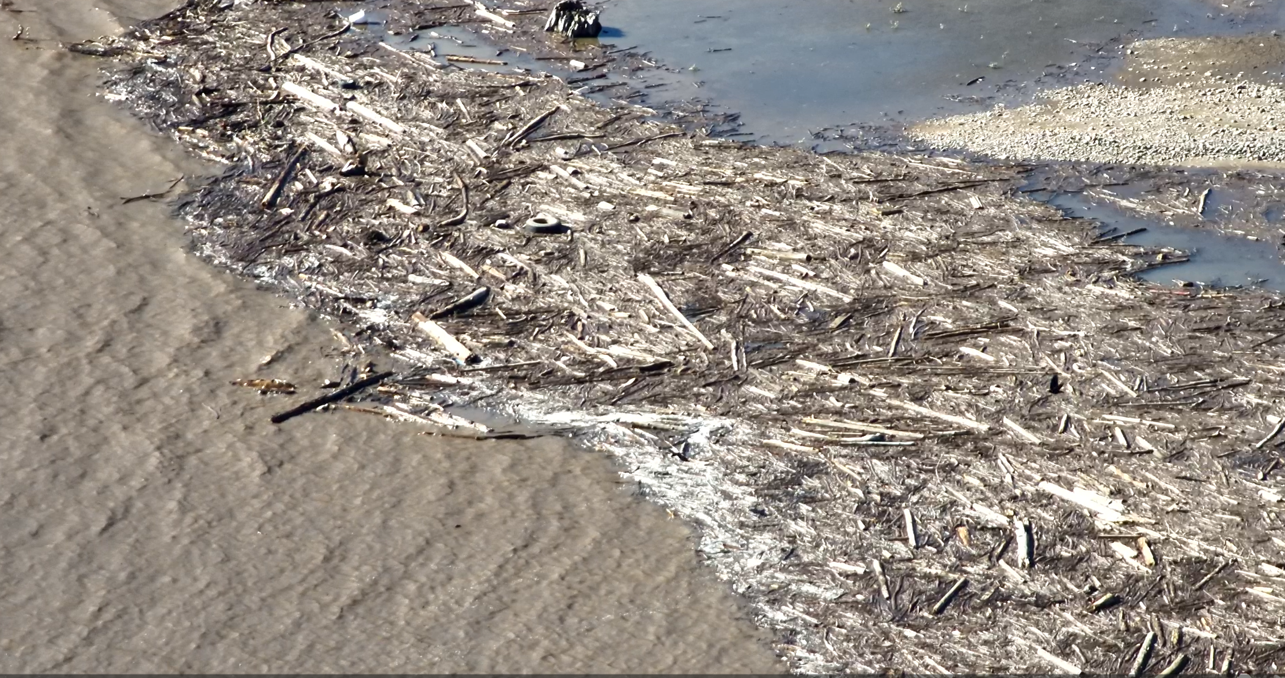

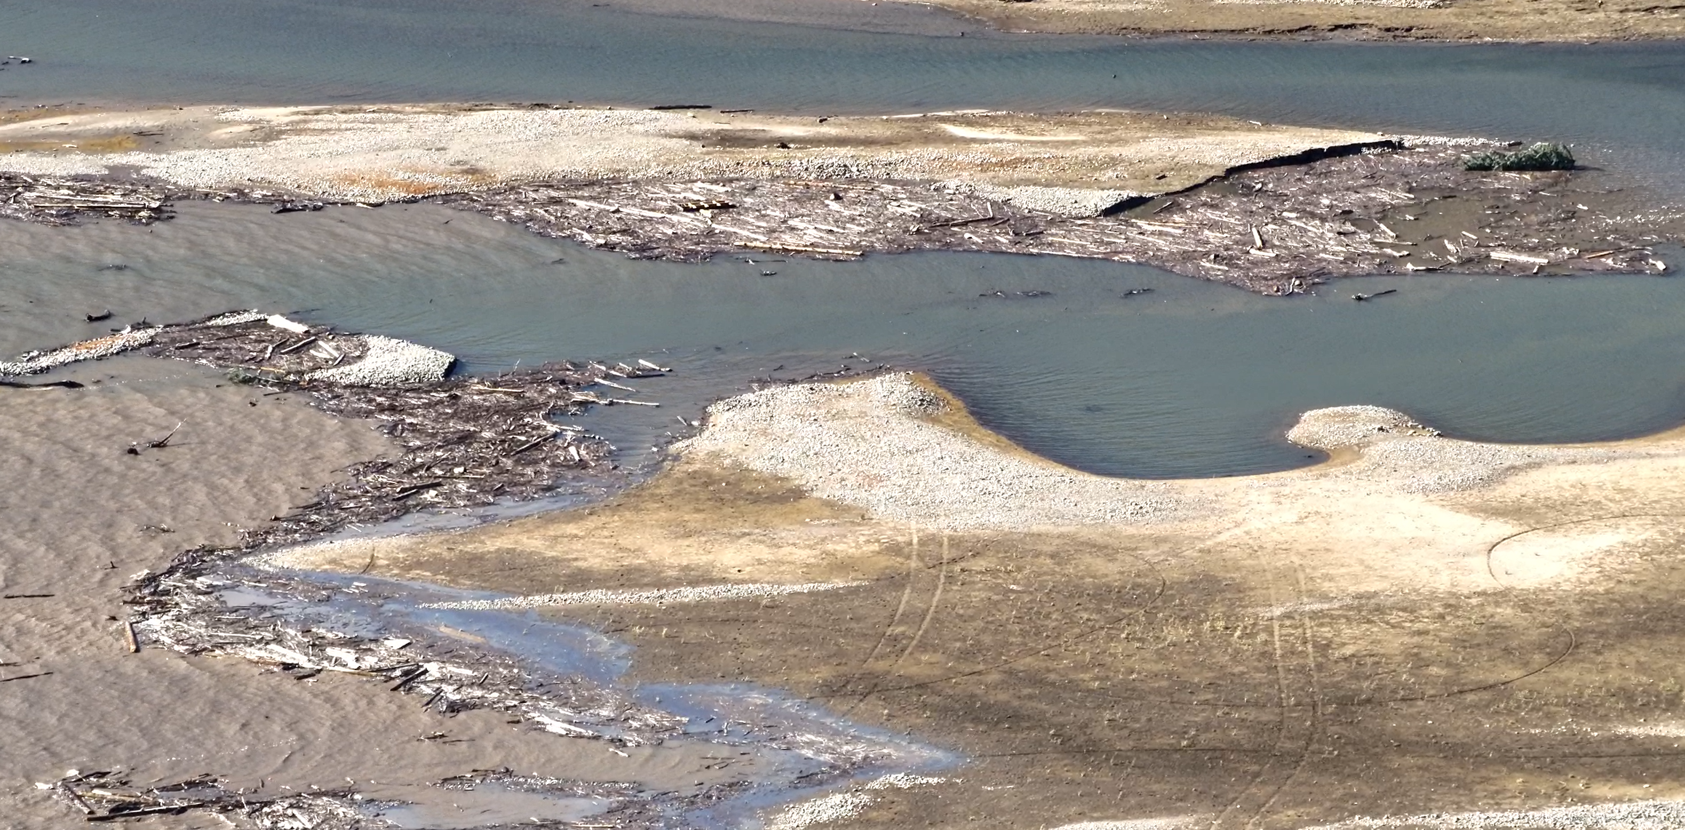
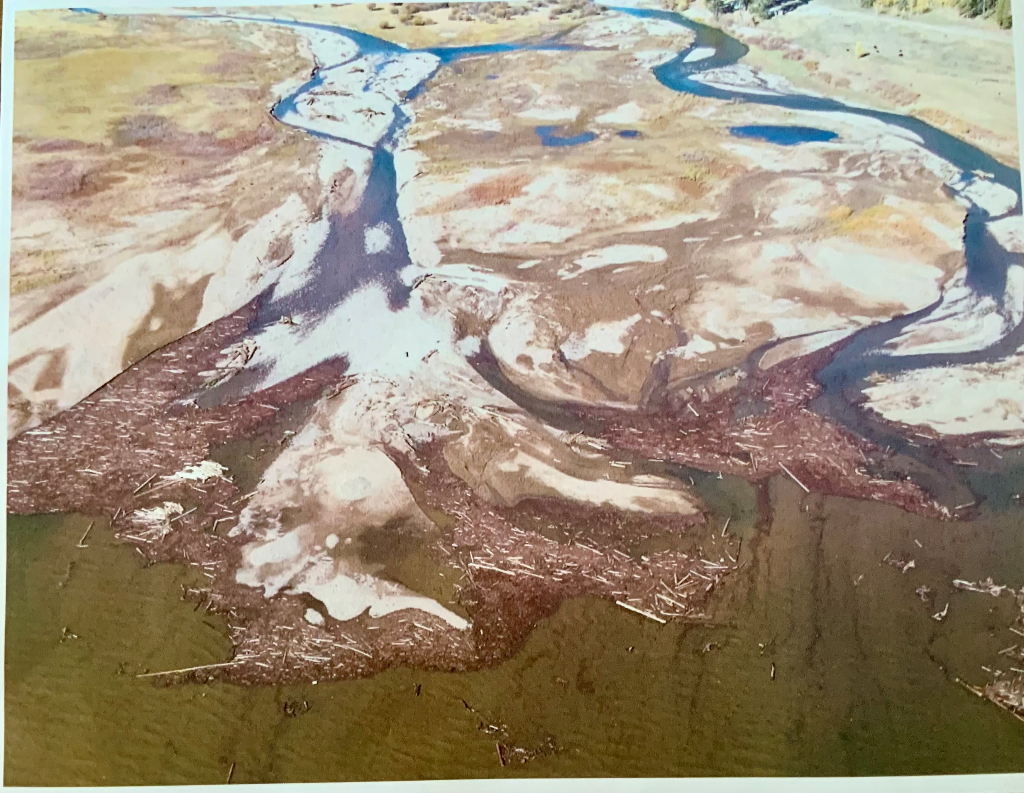
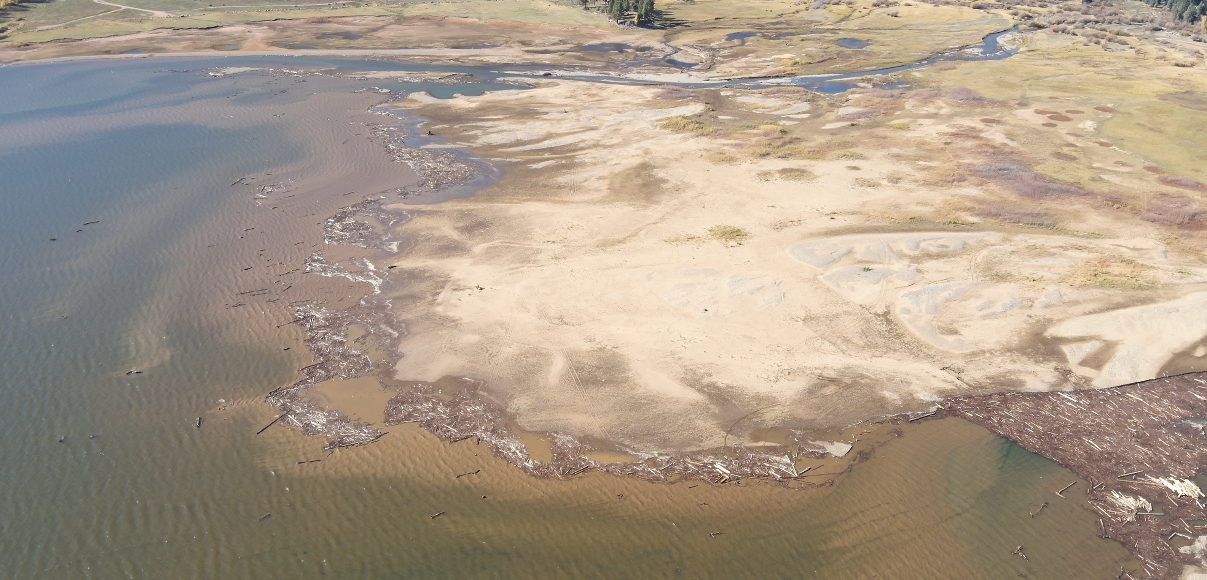

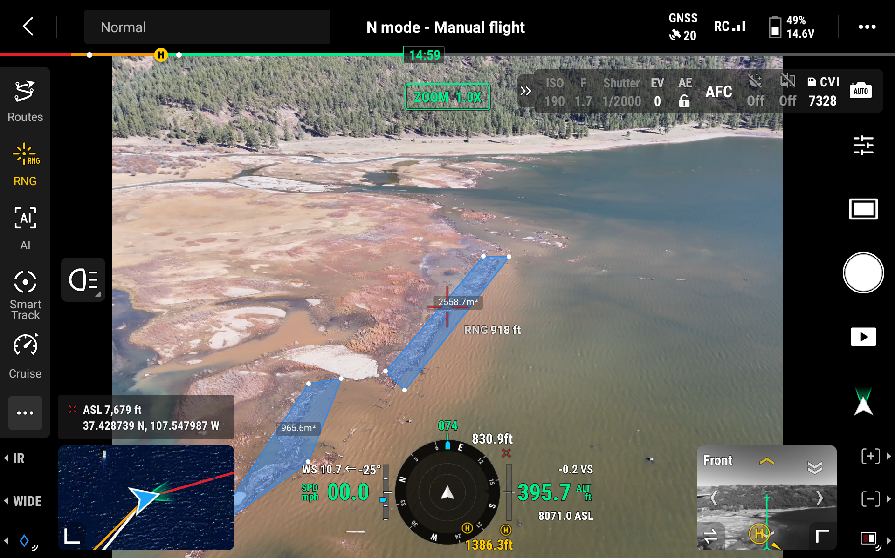
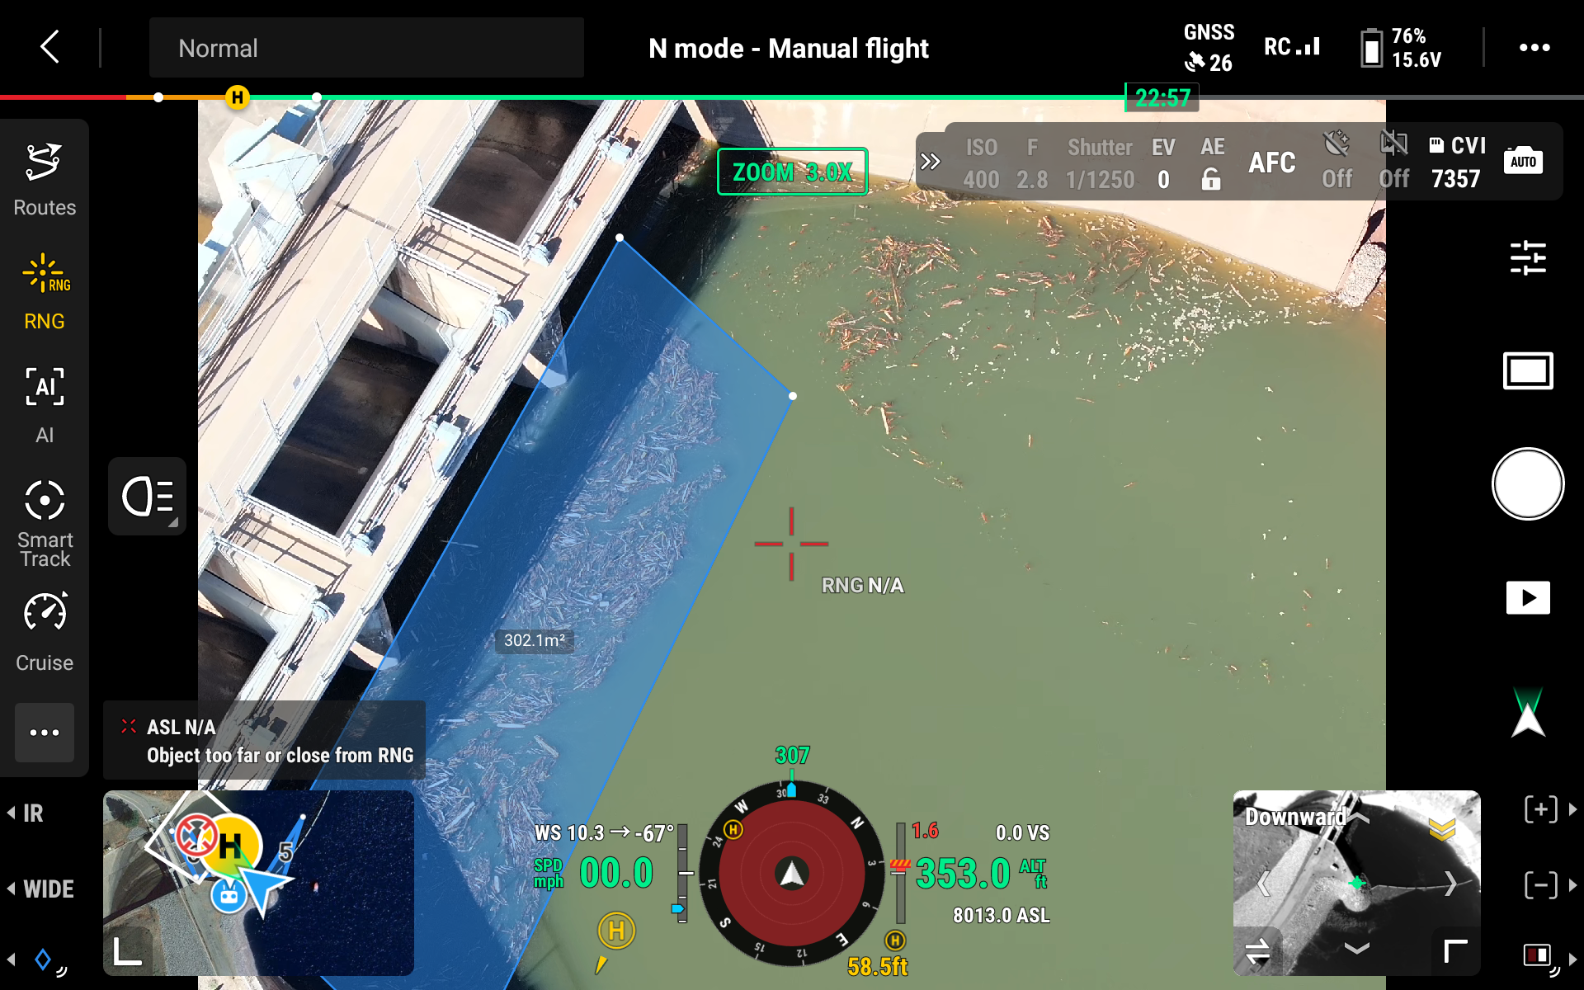

APPENDIX C.
Cascade Timber Salvage’s Bid Proposal
and Related Information

From: paul lbarjranch.com <paul@lbarjranch.com>
Date: Wed, Nov 5, 2025 at 10:54 AM
Subject: Debris removal bid
To: Ken Beck <beckranch74@gmail.com>

Ken,
Here is a bid packet for the debris removal from the north end of Vallecito. If you have any questions or comments please feel free to reach out anytime.

Thanks Andy

Sent from my iPhone

Disclaimer: The information is provided as is without warranty of any kind, either express or implied, including but not limited to the implied warranties of merchantability and fitness for a particular purpose. In no event shall La Plata County be liable for any damages whatsoever including direct, indirect, incidental, consequential, loss of business profits or special damages.
Map Scale
1 inch = 1101 feet
11/5/2025
🌲 Scope of Work Narrative: Cascade Timber Salvage Debris Removal

- Project Overview and Objective

Cascade Timber Salvage (the "Contractor") will execute a debris removal and mitigation project focused on the north end of Vallecito Lake. The primary objective is to eliminate flood-generated debris located in shallow waters and along the shoreline to restore safety, navigability, and aesthetic integrity to the area.

- Scope of Work (Specifics)

The Contractor is responsible for the following activities:

- Debris Removal and Extraction

• Target Area: The initial work area is defined as the shallow/shoreline debris along the north end of Vallecito Lake, extending inland and into the lake from the high-water mark. Specific work zones are referenced in the attached North End Project Map.

• Methodology: The Contractor shall use appropriate machinery and labor to remove debris from the designated areas, utilizing Best Management Practices (BMPs) to minimize shoreline erosion and water turbidity during extraction.

• Level of Effort: The Contractor will remove debris to the best of their ability, prioritizing large hazards, while ensuring compliance with all environmental protection measures.

2. Staging and Material Handling

• Debris Transportation: All recovered debris will be promptly transported from the shoreline work areas to the two designated, pre-arranged Staging Areas (reference Map locations).
• Sorting for Salvage: At the staging areas, the debris will be sorted to maximize material reuse.

◦ Salvage Material: Timber and wood debris suitable for firewood and other commercial/non-commercial uses will be segregated.
◦ Residual Debris: Non-salvageable vegetative material, mixed waste, and small organic debris will be separated for disposal.

3. Debris Mitigation (Disposal)

• On-Site Burning: The primary method of disposal for non-salvageable, clean vegetative debris will be controlled burning within the designated staging areas.
◦ The Contractor is responsible for securing the necessary burn permits from Upper Pine Fire Protection District and adhering strictly to all permit conditions, including weather restrictions and fire suppression readiness.
• Non-Burnable Debris: Any non-combustible material (e.g., metal, plastic, concrete, non-vegetative trash) collected as mixed debris must be separated and hauled off-site for legal disposal at a permitted landfill or recycling facility by the Contractor.

III. General Requirements
• Access: The Contractor will utilize only approved access routes and staging areas as shown on the attached map.

SUBJECT: Immediate Mobilization Proposal for Emergency Debris and Log Jam Removal (2025 Southern Colorado Flood Event)
Dear Mr. Beck,
In response to this disaster and the resulting immediate threats to public health and safety in La Plata County, we are writing to offer our full resources and specialized equipment for immediate deployment.
We are prepared to mobilize immediately.
We understand the urgent nature of the current situation, particularly the impassable roads, breached levees in the Vallecito area, and the widespread debris threatening critical infrastructure. These conditions, which endanger lives and prevent access by emergency services, constitute a "public exigency" that, under federal regulation 2 CFR § 200.320, allows for the use of noncompetitive (sole-source) contracts to avoid the "unacceptable delay" of a competitive bidding process.
As a local firm with an owner-operated fleet of heavy logging equipment (log skidders, dozers, root rakes, and excavators) staged in the region, we are uniquely positioned to assist your teams immediately.
Our core capabilities are ideally suited for this event:
1. Rapidly clear public rights-of-way and evacuation routes.
2. Remove large-scale vegetative debris and log jams from critical infrastructure, such as bridges and levees.
3. Extract hazardous trees, root balls, and stumps from public property.
Our team is experienced in heavy debris cleanup and understands the documentation and monitoring requirements for the FEMA Public Assistance program.
We are prepared to provide detailed equipment and labor logs, load tickets, and all necessary data to ensure Pine River Irrigation District receives full and timely reimbursement for this emergency work.
We have attached a one-page Capability Statement for your review.
Cascade Timber Salvage is ready to deploy our equipment and operators as soon as you give the word. We are here to help our community recover.
Sincerely,

Andrew McCoy
Cascade Timber Salvage
c. 970-946-4522
Andrew.McCoy@msn.com

CASCADE TIMBER SALVAGE CAPABILITY STATEMENT
c. 970-946-4522 | Andrew.McCoy@msn.com

EMERGENCY FLOOD DEBRIS REMOVAL & WATERWAY MITIGATION
COMPANY SUMMARY
Cascade Timber Salvage is a local Southern Colorado timber and heavy equipment firm specializing in large-scale logging and land clearing. We are owner-operators of a full fleet of specialized logging and earth-moving equipment. In response to the October 2025 flood disaster, we are immediately available to deploy all equipment and personnel to La Plata and Archuleta counties to address immediate threats to public health, safety, and infrastructure.
CORE COMPETENCIES
• FEMA Category A Debris Removal: Clearance, removal, and disposal of vegetative debris, sand, mud, and silt from public property and rights-of-way.
• Waterway Debris & Log Jam Removal: Extraction of trees, root balls, and debris from rivers, streams, and canals, specializing in high-risk snags threatening bridges, culverts, and levees.
• Public Right-of-Way (ROW) Clearing: Rapid clearing of downed trees and debris from impassable roads and evacuation routes to restore emergency access.
• Hazardous Stump & Root Ball Extraction: Removal and disposal of hazardous stumps and root systems from public property in accordance with FEMA policy.
• Site Preparation & Streambank Stabilization: Earth-moving, excavation, and implementation of streambank stabilization measures, including rootwad revetments and engineered log jams.
DIFFERENTIATORS: THE CASCADE ADVANTAGE
• Immediate Mobilization: As a local firm, our fleet and operators are on standby and can be mobilized to any site in La Plata or Archuleta County within hours, not days.
• Specialized Logging Fleet: We own and operate the specialized equipment (log skidders, dozers with root rakes, feller bunchers) required for the efficient removal of the large-scale vegetative debris and log jams caused by this event.
• Mountain Terrain Experts: Our team has deep expertise in the difficult terrain and complex environmental conditions of the San Juan region.
EQUIPMENT FLEET
• Log Skidders
• Crawler Dozers w/ Root Rake Attachments
• Hydraulic Excavators w/ Grapples & Buckets
• Feller Bunchers & Delimbers
• Brush Chippers / Tub Grinders
• Dump Trucks, Lowboys, and Support Vehicles
COMPANY DATA
• Company Name: Cascade Timber Salvage
• Contact: Andrew McCoy
• SAM.gov UEI: QJRBJLMKQU6
• CAGE Code: 8JGQ3
• NAICS Codes:
o 562119: Other Waste Collection (Debris Hauling)
o 113310: Logging (Timber Salvage)
o 562910: Remediation Services (Environmental Cleanup)
o 238910: Site Preparation Contractors

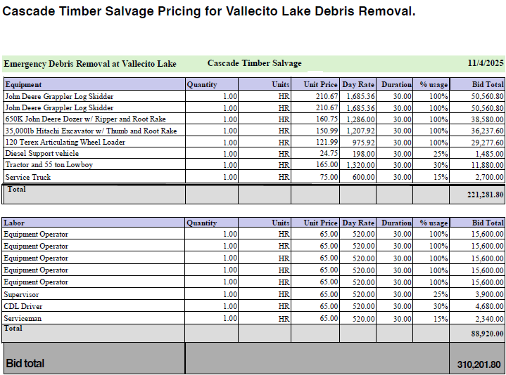

Photos of Cascade Timber Salvage Specialized
Equipment Capability

Photos of Cascade Timber Salvage Specialized Equipment Capability

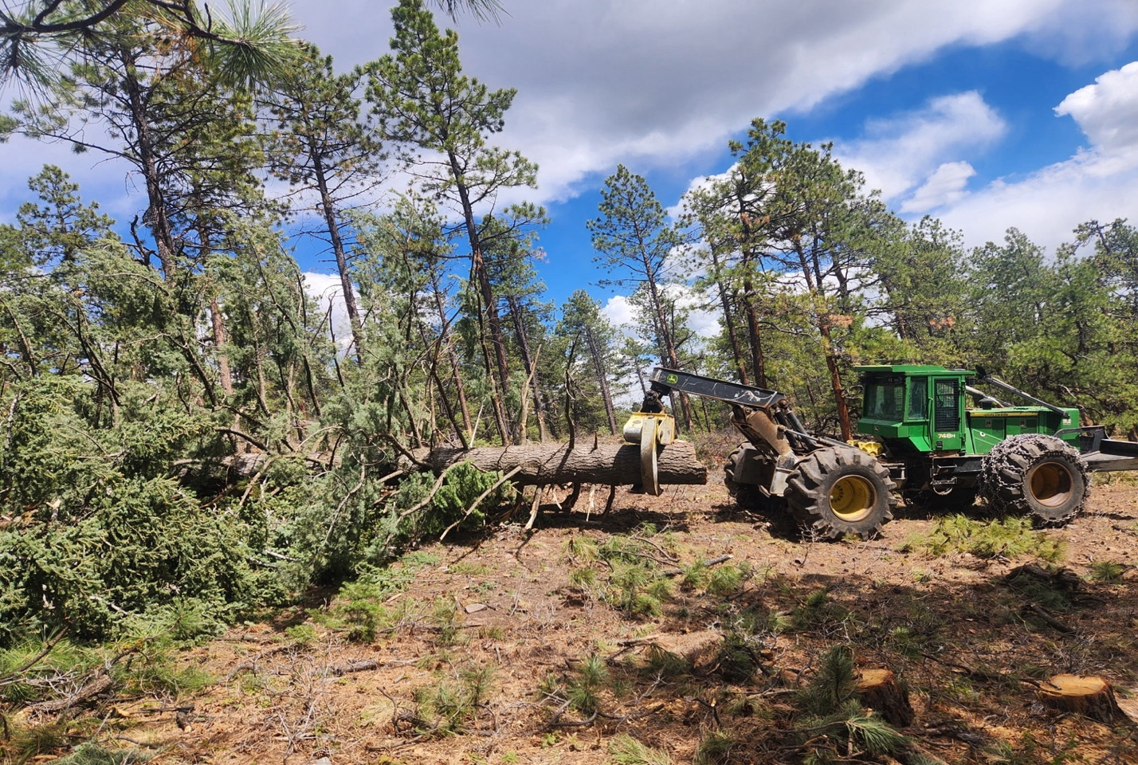

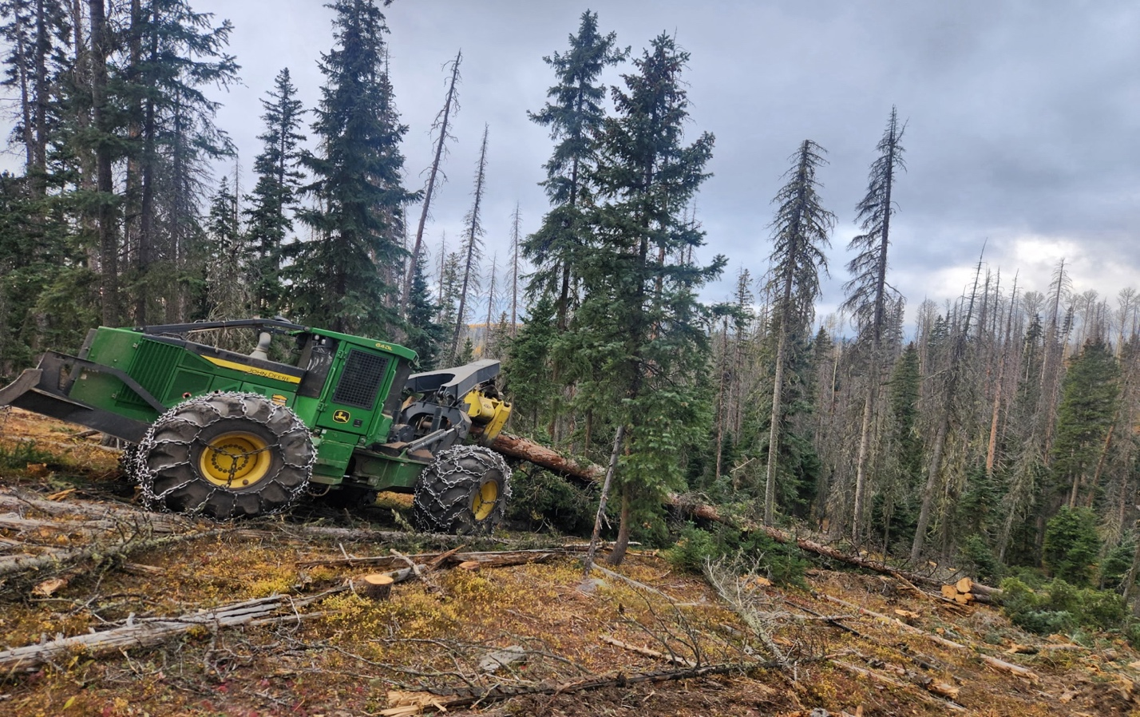

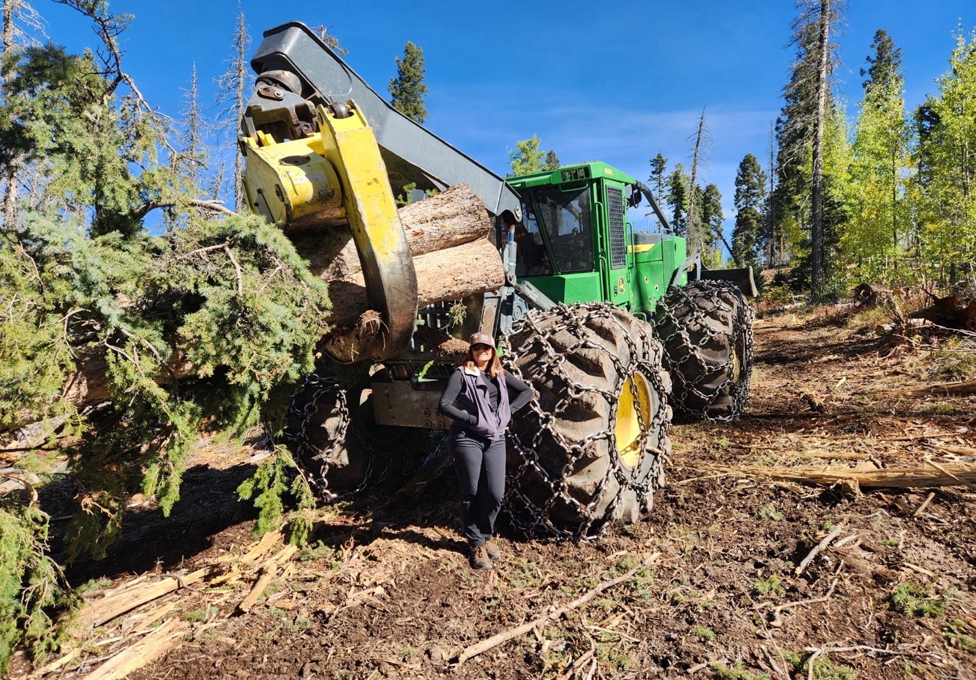

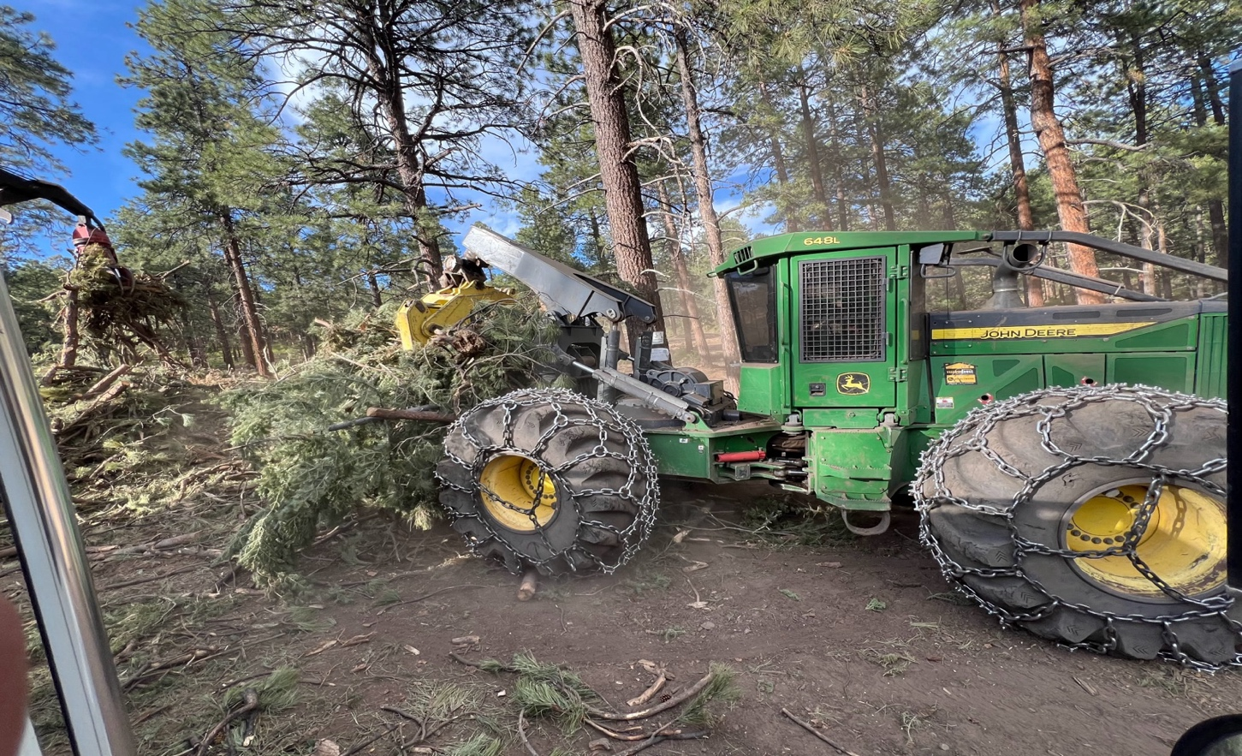

APPENDIX D.
Bureau of Reclamation / Pine River Irrigation District November 13, 2025, Zoom Conference Call

BOR/PRID Zoom Call- Thursday November 13, 2025
Debris in Vallecito Reservoir.
The following individuals participated in the call:
BOR - Bart Deming, Acting Area Manager, Western Colorado Area Office (WCAO),
Four Corners Construction Office; Reece Carpenter, Resource Division Manager, WCAO, Grand Junction; Kelsey Deckert, Durango BOR, Chief, Facilities Maintenance Group; and, Eric Creedon, Southern Lands & Recreation Group Chief - BOR.
PRID - BOD and Superintendent - Allen McCaw, President; Nate Wright, Vice President; Steve Pargin, Secretary; and Ken Beck, Superintendent.
Preface
On November 6, 2025, the BOR recommended that the PRID initiate the following action to remediate the debris issue in Vallecito Reservoir based on the 2009 Amended MOA, Water Based Recreation Agreement between BOR, BIA and PRID, Amendment at Section 5 - Safety.
To avoid debris settlement over the winter and risks to clogging of the outlet works intake
and provide protection of recreators next summer, it is recommended that at least two
major debris collection efforts be undertaken as part of this cleanup program: one in the
winter of 2025/2026 and one in the late-spring /early-summer of 2026. There may be
additional collection needs beyond this recommendation, however, these can likely be
included in PRID’s typical operation and maintenance program following this more substantial effort.
I explained to the call participants that the PRID was feeling a bit alone in the huge effort of cleaning up the debris from the October 2025, 100-year flood event at Vallecito Reservoir. We touched on the above language at Section 5 - Safety.
The question was raised on the principles of law regarding: 1) The “intent” of the language at Section 5. PRID does not believe that the language addresses extraordinary events. Specifically, the 100-year flood event of October 2025. And 2) The principle of “reasonability.” PRID believes that it is unreasonable that the Pine River Irrigation District and its shareholders should stand alone in the expense and liability for remediating the debris cleanup.
Bart commented that he had conferred with BOR staff earlier in the day on the problem before us. The overall perspective from this meeting resulting in concurrence with PRID’s above concerns. Bart asked Kelsey and Reece to share their perspectives on BOR’s discussion earlier this morning. Kelsey shared that she had made a personal visit to Vallecito Reservoir to get a better understanding of the scope of the debris issue. She said that she did not believe that any immediate action needs to be pursued. The amount and location of the debris did not appear to warrant immediate action as

was proposed by BOR on November 6th. Reece’s comments were supportive and aligned with Kelsey. Bart commented that BOR did not want PRID to interpret that BOR was stepping aside and letting PRID shoulder the burden of the flood event. He emphasized that BOR does not have a funding source to help alleviate the financial burden of debris management and cleanup. However, BOR is more than willing to assist with the approach, planning, limited manpower, and minimizing the liability of the associated language at Section 5 in the MOA. BOR is more than willing to help PRID find the least financially impactive approach to addressing the debris cleanup issue including extending the effort out over a longer interval than is optimal, and the development of public awareness program/notices and the like.
As a group, we discussed that our first order of business is to protect the intake structure to the outlet works. PRID will continue its pursuits in this regard (i.e., the recommendation and pricing of a buoy debris barrier around the intake vortex, etc.). Secondly, PRID will continue its development of a reasonable funding effort to clean up the debris field, including adding a line item in our upcoming annual budget for funding a summer help effort focused on the debris cleanup over time. Other cleanup thoughts and approaches will be considered by BOR and PRID staff as they develop.
The call ended with goodwill and good feelings. Bart commented that he enjoyed the partnership arrangement between BOR and PRID. PRID representatives expressed like sentiment.
The call concluded.

APPENDIX E.
Protective Debris Buoy Line
- Layout Option 1
- Layout Option 2
- Pricing Quote 1
- Pricing Quote 2
- Image of Reconfigured Preferred Plan -Option 2

Layout Option 1

Disclaimer: The information is provided as is without warranty of any kind, either express or implied, including but not limited to the implied warranties of merchantability and fitness for a particular purpose. In no event shall La Plata County be liable for any damages whatsoever including direct, indirect, incidental, consequential, loss of business profits or special damages. Map Scale1 inch = 1101 feet 11/12/2025

Layout Option 2

Disclaimer: The information is provided as is without warranty of any kind, either express or implied, including but not limited to the implied warranties of merchantability and fitness for a particular purpose. In no event shall La Plata County be liable for any damages whatsoever including direct, indirect, incidental, consequential, loss of business profits or special damages. Map Scale 1 inch = 376 feet 11/12/2025

November 13, 2025
Vallecito Marina
Attn: Kallen Elkins
14772 County Rd 501
Bayfield, CO 81122
Re: WaveEater Proposal #2511131
Hi Kallen:
I am pleased to provide you a quotation for materials to construct a WaveEater 600 foot single line attenuator. The WaveEater would be constructed in 12 - 50' sections.
This is the same configuration we quoted in 2020.
Scope of Work - Attenuator constructed in 12 - 50' sections.
• Attenuator to consist of 90 units of WaveEater Model 3636 in Orange.
• Attenuator to consist of 90 units of WaveEater Model 3636 in Yellow
• Supply 700 feet of 1/2" Stainless Steel Cable.
• Supply 600 feet of 1” flexpipe
• Supply 24 HDPE Washers.
• Supply 13 anchor buoys
• Supply 5 Regulatory Buoys with Solar Amber Lights.
• All Connecting hardware stainless steel
• Supply 800 feet of Galvanized Anchor Chain.

- Total price for materials, manufacture and delivered $105,200.00
- Estimated lead-time 3 - 4 weeks ARO, depending on current production schedules.
- Terms: Payment of 30% deposit with order, balance at shipment.
- Contractor to build and install 13 - concrete anchors, and 5 – 300 lb buoy anchors.
- Contractor should plan on 3 days for installation, depending on wind and weather conditions.
The WaveEater attenuator materials are manufactured and shipped from Littleton, Colorado.
This proposal is in effect for thirty days.
Thank you for this opportunity.
Sincerely.
Peter W. Odenbach
WaveEater, LLC (407) 630-2692
peter@waveeater.com

Pricing Quote 1

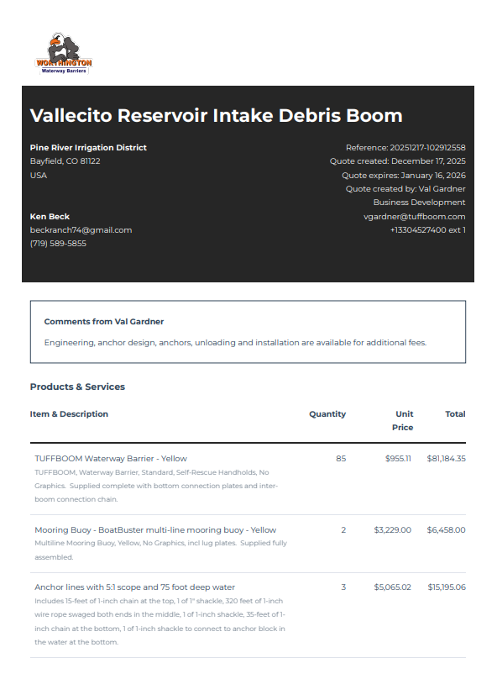
Pricing Quote 2


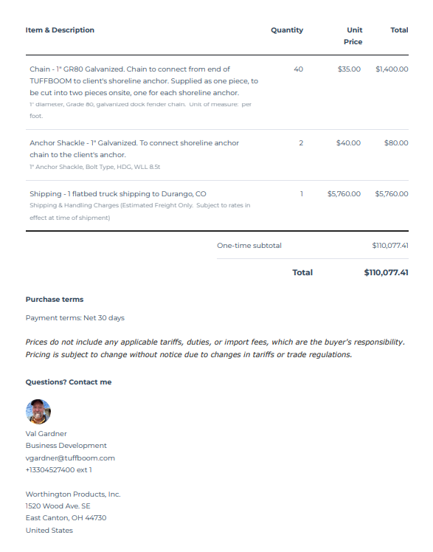

Image of Reconfigured Preferred Plan - Option 2
Under BOR and PRID Evaluation / Consideration

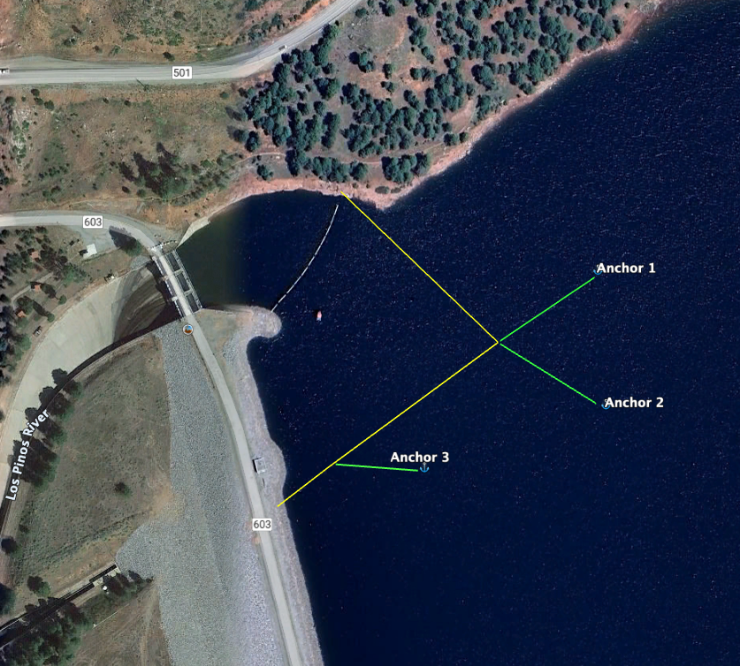

APPENDIX F.
Summary of January 8, 2026, Meeting among NRCS/UPFPD, BOR and PRID Representatives – Vallecito Reservoir Debris Management and Funding Assistance Opportunities, October 2025 100 Year Flood Event

(Final)
Summary of Thursday, January 9, 2026, Meeting On Managing the Debris
In Vallecito Reservoir from the October 2025, Vallecito Creek
100-Year Flood Event

The meeting was held at the PRID Office. The following individuals attended in person: Mike Canterbury (PRID Dam Tender); Chrissy Wright (PRID Office Manager); Tammy Smith (PRID Office Assistant, and Vallecito Creek resident); Mike Muir, NRCS/UPFPD; Ken Beck, PRID Superintendent. The following individuals participated via Zoom conference call: Reece Carpenter, Resource Division Manager, WCAO, Grand Junction, BOR; Steve Pargin and Nate Wright, PRID Board of Directors.

The purpose of the meeting was twofold. First, update the participants on the current management/status of the debris, that has accumulated in Vallecito Reservoir from the October 2025 flood event. Second, develop a consensus among the BOR, PRID, and the recently initiated NRCS/UPFPD process that is providing federal financial relief to assist in the disaster recovery, on how best to optimize debris management in the future. Copies of the PRID document: Vallecito Dam and Reservoir, Bayfield, Colorado, Debris Cleanup Needs Study, January 8, 2026, were distributed before the meeting.

Ken introduced Mike Muir. He then provided brief background comments to bring the participants current on the debris situation. He informed the group that Mike M. is looking for the PRID to provide two subcontracts to seek and qualify for federal funding assistance. The first subcontract will be to initiate the cleanup of the debris in the reservoir via Cascade Timber Salvage, a locally owned business. Second, the detailed plans and costs estimate for the installation of a protective debris boom or buoy line, to prevent debris from adversely affecting the intake structure, of the outlet works at the south end of the Reservoir near the Dam.

Mike M. commented that the debris cleanup opportunity with Cascade Timber Salvage (CTS) is losing traction. CTS’s proposal focused on removing the debris that, at that time, was 100 percent concentrated at the north end of the lake. Within a short period of time the debris has dispersed around the Lake. Consequently, this proposal is looking much less favorable.

Mike said that the second contract, installation of the protective buoy line around the intake structure, is a very likely candidate to receive federal funding assistance. He clarified a comment that was made regarding PRID cost-share amount being 25 percent of the total installation cost. Mike said that PRID’s cost share amount, due to state funding opportunities, would be approximately 12.5 percent, or half of the originally planned cast-share contribution.

Ken commented that over the last 24 to 48 hours, following BOR’s comments on the above PRID document, BOR has cautioned that a thorough investigation and analysis of the proposed protective

“boom line” installation need to be conducted. BOR’s experience, over its vast projects throughout the west, has revealed negative issues with similar historical installations on other projects (i.e., The attraction, collection, and concentration of debris around the boom line can increase dramatically, depending on its orientation and design, causing significant maintenance issues and possibly causing more debris to accumulate around the intake, etc.). Consequently, BOR will need to review and analyze potential impacts before approving installation of the protective line.

Reece commented that, in most cases, the debris appears to take care of itself (i.e., Settling out on the reservoir high water line, sinking to the bottom of the reservoir, actions of wood gathers, etc.)

Ken asked Mike M. what timeframe we are looking at to have a BOR approved design and cost estimates in the hands of NRCS/UPFPD to qualify for funding consideration. Mike said the information will need to be turned in within the next 30 days (February 9-ish). He is aware that this will be a “heavy lift” for BOR to meet this deadline. Reece commented, that due to BOR’s current staffing shortage, this will be difficult to accomplish. He qualified his comment that he will do his best, but he cannot make an absolute commitment to that effect. Mike M. commented that he understood the dilemma and that he would do what every he could on his end to be as flexible as possible.

The subject of “public perception” surfaced and the intensity of the high emotions that currently exist with the residents at Vallecito. Ken said that this is a main reason that the PRID has developed the above detailed document regarding the flooding and PRID effort to demonstrate “due diligence” in our (PRID’s) addressing the disaster. Criticism and emotionally charged public interactions and misinformation are on a high. Reece commented that he understood and realized that the problem is increased when public concerns and federal oversight concerns aren’t the same. All agreed that it is a tough spot we find ourselves in.

Ken asked Reece if an outside entity was to be considered for a debris cleanup effort, what environmental considerations would be required. Reece said that NEPA compliance would be required. However, it could be a condensed version. He added that a cultural resource survey, a less flexible review/study, would be required as well.

Steve asked if BOR would consider assuming BOR and PRID agree to move forward with the installation of the boom line, assigning a portion of the annual funds they receive from PRID to help offset the cost of the installation with the PRID shareholders. Reece commented to the effect that he was not sure about the financial flexibility, but that it could be considered.

The meeting concluded with all agreeing that we are in a tight spot. If BOR’s research concludes that the debris boom is a beneficial concept, worthy of implementation, we have a very narrow window to make that happen. We will all do our best and accept the result of our efforts.

The meeting Adjourned.

